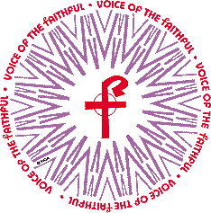

Organizational Structures of the Catholic Church

A Primer

Introduction

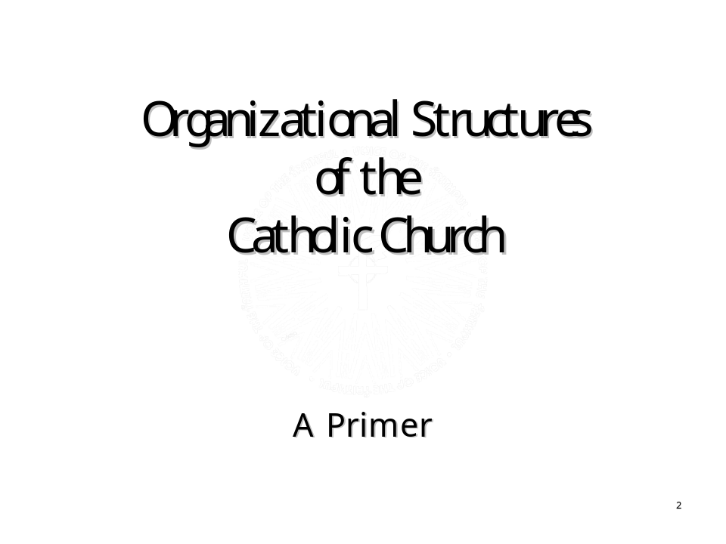

Narration
“This document is an initial effort to identify church structures both as they are defined and as they actually function. This is a necessary first step in identifying areas that need change. Change may be achieved by renewing existing structures that may not have been effectively implemented, or by the formation of new structures, such as safety committees.”

About this Document
This is a primer in the sense that is seeks to impart a basic understanding, and is not an exhaustive or highly detailed treatment of the subject.
Governing laws and the structures that are established and regulated by them are discussed, and some terms and titles are explained.

Presentation Note
For presentation in real time, the next slide which contains the quote for “At the Dawn of a New Millennium” is used for display before the presentation begins, and then used again as the second slide in the presentation. Display slide 2 before the actual presentation begins, then move back to the title slide for your initial remarks, and then back through slide 2 and the rest of the slides.

At the Dawn of a New Millennium

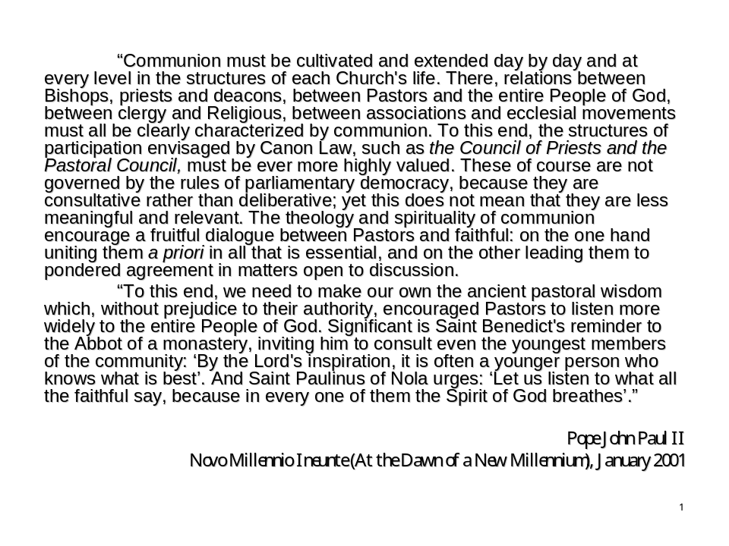

Narration
“We begin and end this presentation with the words of Pope John Paul II. Both this quote and the final one call the whole church to work for true communion, and for better structures of participation, consultation and shared responsibility.”

VOTF Structural Change Statement

VOTF Structural Change Statement

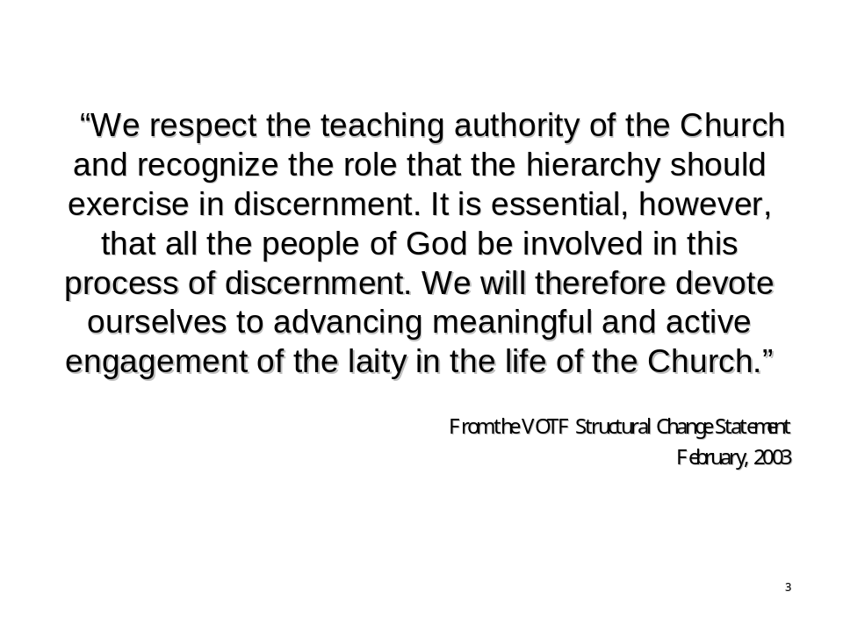

Narration
“In February of 2003 the VOTF representative council approved the Structural Change Statement, in order to begin to define what VOTF means by structural change and how we will work to shape it within the church. It reads in part: We respect the teaching authority of the Church and recognize the role that the hierarchy should exercise in discernment. It is essential, however, that all the people of God be involved in this process of discernment. We will therefore devote ourselves to advancing meaningful and active engagement of the laity in the life of the Church.” This is the focus of all VOTF efforts for structural change.”
The full text of the statement may be found on the VOTF website, www.votf.org.” It is reprinted below

Text of the VOTF Structural Change Statement

Statement of Principle:
VOTF is motivated by the conviction that the whole Church should respect the dignity and intelligence of all its members (clerical and lay), and acknowledge the right and responsibility of the laity, flowing from their baptism, to use their God-given gifts for the good of the Church.

Goal - To shape structural change within the Church:
We respect the teaching authority of the Church and recognize the role that the hierarchy should exercise in discernment. It is essential, however, that all the people of God be involved in this process of discernment. We will, therefore, devote ourselves to advancing meaningful and active engagement of the laity in the life of the Church.

Approach:
We seek to achieve this goal through prayer, dialogue and education involving clergy and laity. Our approach is to work from the parish* level upwards, both because it is necessary, and because it is possible. We recognize that it is on the level of the parish and in the context of parochial norms that our children have been grievously injured. We believe that, if we can make our local faith communities models of consultation and openness, analogous changes will follow at higher levels.
In order to move toward the vision of the Second Vatican Council, we believe it is vitally important that the faithful of each parish engage in, and enthusiastically support, the formation and actions of Pastoral and Finance Councils and Safety Committees. We must empower the laity to protect our children and all the people of God.

At the parish level, VOTF will:
Emphasize lay involvement as a starting point that is crucial to the health of the parish and of the Church as a whole.
Work to enhance education on the rights and responsibilities of the laity and clergy, and provide educational support and resources such as a primer on Church structure.
Work to empower active, collaborative, effective and representative Pastoral Councils, Finance Councils, and Safety Committees in every parish.
Support Parish Pastoral Councils (PPCs) by providing resources for formation of PPCs, and sample PPC foundation documents.
Work vigorously for immediate, meaningful lay consultation in the process of pastoral selection.

At the diocesan level, VOTF will:
Work to empower and support active, collaborative, effective and representative Diocesan Pastoral Councils, Finance Councils, and Safety Committees in every diocese.
Work to create and support Pastoral Councils, Finance Councils and Safety Committees on intermediate levels, such as vicariate and region if the diocese is so divided.
Work vigorously for immediate, meaningful lay consultation in the process of pastoral selection.
*Parish throughout this text means both intentional and geographical communities of faith.
The full text of this statement may be found on the VOTF website at http://www.votf.org/Structural_Change/structural.html
Overview

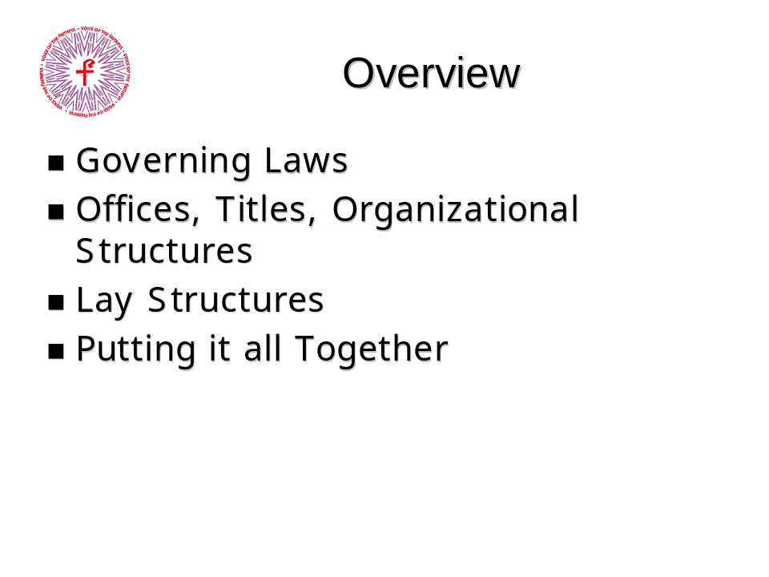

Narration
“This presentation is divided into four sections.
In the first one, Governing Laws, we look at the different codified laws that govern the Church. In the second, Offices, Titles, and Organizational Structures, we look at how the clergy is organized. In the third section, Lay Structures, we take a look at the structures in which the laity play a key role. Finally, in the last section, Putting It All Together, we look at how the laws, clergy, and laity work together in the Church. We also consider some of the recommendations VOTF has made for better structures of participation, consultation and shared responsibility.
At the end of each section we’ll have an opportunity to review points for consideration or discussion in that topic.”

Key Areas
- Governing Laws
- Titles, Roles, and Organizational Structures
- Lay Structures
- Putting It All Together

Governing Laws

Introduction
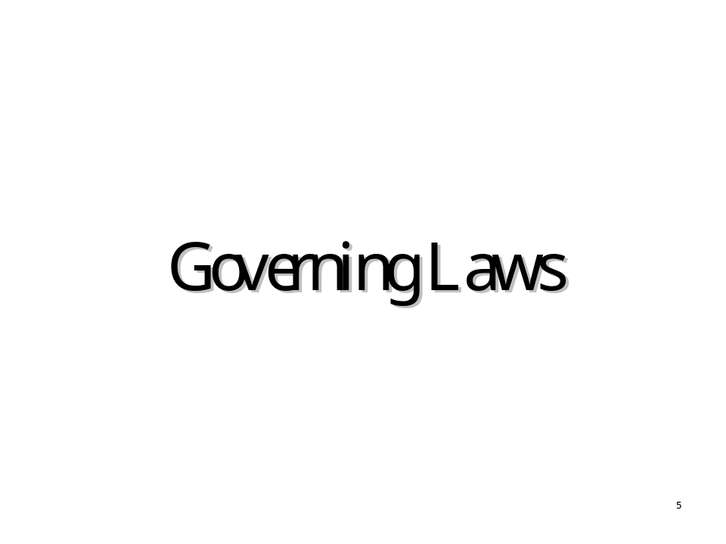

Narration
“The Catholic Church is governed overall by Canon Law, and the most recent Code of Canon Law was promulgated in 1983. The word “Canon” comes from the Greek word “Kanon” which means a rule or practical direction. The term ‘promulgate’ means officially enact the law, As with civil laws, the promulgating authority determines the scope of the rule. For instance, a city ordinance enacted by a town council is valid only so far as the city limits, but a federal law enacted by the national government is valid throughout the nation.
In this section, we will discuss the four levels of governance; Canon Law, Episcopal Directives, Diocesan Statutes and Norms, and Parochial norms and rules.”

Governing Laws

Types of Governing Laws
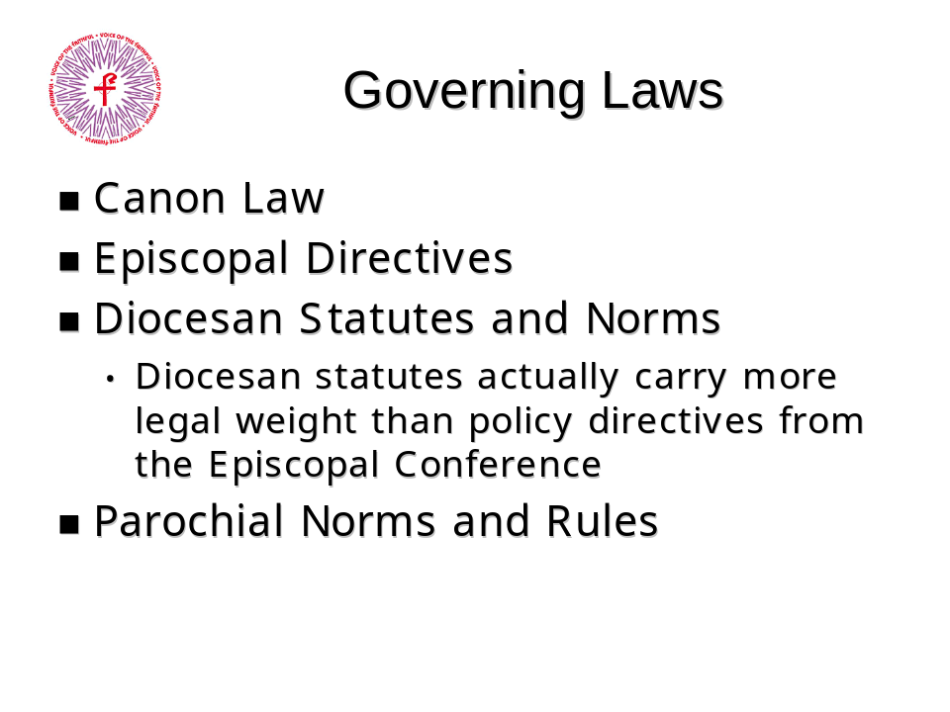

Narration
“The governing laws on this slide are listed from the largest geographical area to the smallest but they are not listed in order of legal weight, since in that sense, Diocesan statutes actually carry more legal weight within the scheme of Church governing laws than directives from an Episcopal Conference.
As an analogy to the scope and purpose of these different levels of Church governing laws, keep in mind Federal laws, State laws, and Local ordinances. While Federal laws apply to the largest number of people, it is the state laws and local ordinances that are most engaged in everyday life. For example, a state may enact a law that makes littering an offense and set a range for fines. Towns within that state may pass local ordinances setting the fines for that town. To a litterbug, the local town ordinance is much more relevant than the state law since it will determine how much the litterbug will pay for tossing that trash out of the car!
Also, a political entity such as the Organization of American States or the United Nations covers a broader geographical territory than does any individual member nation, but its decisions carry less weight in law because individual sovereign nations join the OAS or the UN voluntarily and do not surrender any of their sovereignty in doing so.
Throughout this section we’ll learn how the layers of governing laws interact with one another and how they affect us on the parochial level.”

Governing Laws

Canon Law
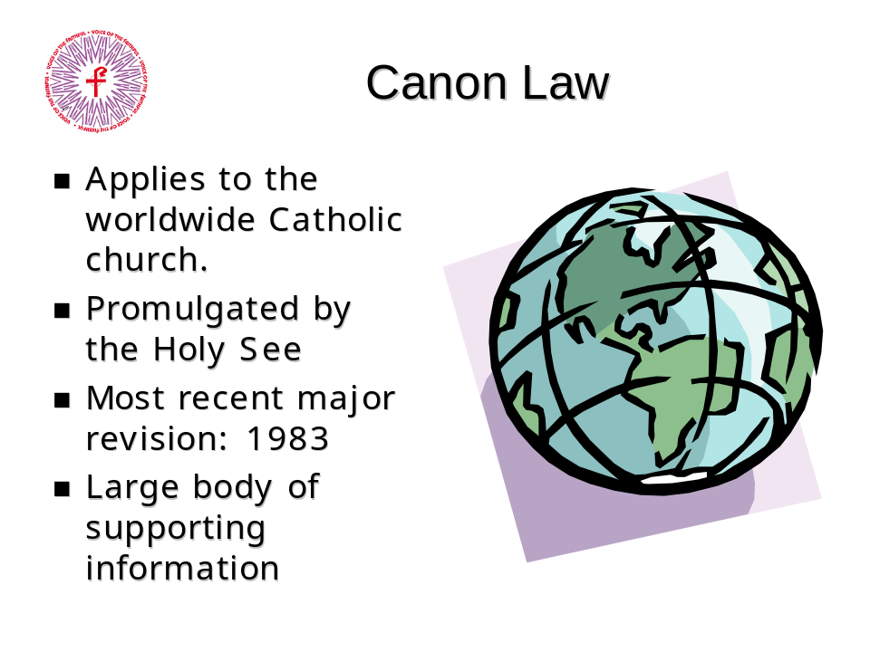

Narration
“Let’s start at the highest level, Canon Law. Canon Law is the highest level of codified law in the Catholic church and applies to the worldwide Catholic community. It is promulgated by the Holy See. The last promulgation of Canon Law was in 1983 under Pope John Paul II.
In addition to the Code of Canon Law, there is a large body of supporting information that is similar to precedents in civil law in the United States.
Because of the scope of Canon Law, it typically allows for adjustment at more local levels. Like any laws, Canon Law can be difficult to read and understand, particularly since the laws are originally promulgated in Latin and are then translated to the vernacular. Some sections are easy to read and understand, others can be much more difficult.
The current code of Canon Law can be found on the internet in English (for example, at http://www.ourladyswarriors.org/canon/) and other languages and is available in print.”

Vatican/Holy See
As a note, the term “Vatican” is often used interchangeably with the term “Holy See” in much the same way as we use the term “Washington” to mean the Federal Government. The Vatican is actually a political entity, like Washington D.C. and has no legislative power over the church. The Holy See is the authority of the church. The term “Holy See” is derived from the word seat (or see) of the Bishop of Rome. This seat is the Papal throne in the Basilica of St. John Lateran, which is the Cathedral Church of the Archdiocese of Rome.

Governing Laws

Episcopal Conference Norms
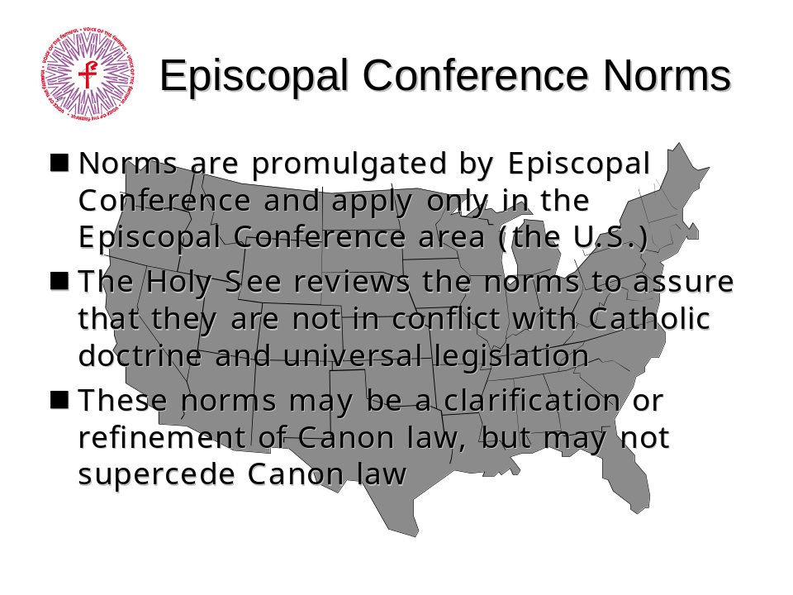

Narration
“An Episcopal Conference is a group of Bishops from a geographical region. In the United States, the Episcopal conference is called the United States Conference of Catholic Bishops, or USCCB. Episcopal Conferences promulgate rules, called ‘Norms’ for their region.
Since the diocesan Bishop is the sole legislator of the diocese, he holds the authority of the execution of the norm within his diocese. Typically, Episcopal Norms provide latitude for local adjustment of the norms to suit the circumstances.
Typically, an Episcopal Norm is a refinement or clarification of an existing Canon Law. In some cases, Norms address issues that are not included in Canon Law, such as Essential Norms for Diocesan/Eparchial Policies Dealing with Allegations of Sexual Abuse of Minors by Priests or Deacons recently approved by the USCCB.”

Text of the Norms
The text of these norms may be found at the USCCB website at http://www.usccb.org

Governing Laws

What is the United States Conference of Catholic Bishops?
The following is from the USCCB website (usccb.org/whoweare.htm):
“The United States Conference of Catholic Bishops (USCCB) is an assembly of the hierarchy of the United States and the U.S. Virgin Islands who jointly exercise certain pastoral functions on behalf of the Christian faithful of the United States. The purpose of the Conference is to promote the greater good which the Church offers humankind, especially through forms and programs of the apostolate fittingly adapted to the circumstances of time and place. This purpose is drawn from the universal law of the Church and applies to the episcopal conferences which are established all over the world for the same purpose.
“The Bishops themselves constitute the membership of the Conference and are served by a staff of over 350 lay people, priests and religious located at the Conference headquarters in Washington, DC. There is also a small Office of Film and Broadcasting in New York City and a branch office of Migration and Refugee Services in Miami.
”The Conference is organized as a corporation in the District of Columbia. Its purposes under civil law are: ‘To unify, coordinate, encourage, promote and carry on Catholic activities in the United States; to organize and conduct religious, charitable and social welfare work at home and abroad; to aid in education; to care for immigrants; and generally to enter into and promote by education, publication and direction the objects of its being.’”

History of the USCCB
The following is from the USCCB website (usccb.org/whoweare.htm):
“In 1917 the Bishops of the U.S. formed the National Catholic War Council (NCWC) to enable U.S. Catholics to contribute funds and commit personnel to provide spiritual care and recreation services to servicemen during World War I. In 1919 Pope Benedict XV urged the hierarchy to join him in working for peace and social justice. In response, the Bishops organized the National Catholic Welfare Council in 1919 and set up the first Administrative Committee of seven members to handle the Council's business between plenary meetings. At that time the headquarters were established in Washington, DC and a general secretary with some staff was appointed.
“The word "Conference" soon replaced "Council" in the organization's title, underlining the fact that it was consultative rather than legislative. At the same time, in 1922 the National Catholic Welfare Conference was created to address such concerns as education, immigration and social action.
“This model continued until 1966 when the National Conference of Catholic Bishops (NCCB) and the United States Catholic Conference (USCC) were established. The NCCB attended to the Church's own affairs in this country, fulfilling the Vatican Council's mandate that Bishops "jointly exercise their pastoral office" (Decree on the Bishops' Pastoral Office in the Church, #38). NCCB operated through committees made up exclusively of Bishops, many of which had full-time staff organized in secretariats. In USCC the Bishops collaborate with other Catholics to address issues that concern the Church as part of the larger society. Its committees included lay people, clergy and religious in addition to the Bishops.
“On July 1, 2001 the NCCB and the USCC were combined to form the United States Conference of Catholic Bishops (USCCB). USCCB continues all of the work formerly done by the NCCB and the USCC with the same staff. The Bishops themselves form approximately 50 committees, each with its own particular responsibility.
The staff work is overseen by the General Secretariat of the conference.

Governing Laws

Episcopal Conference Norms II
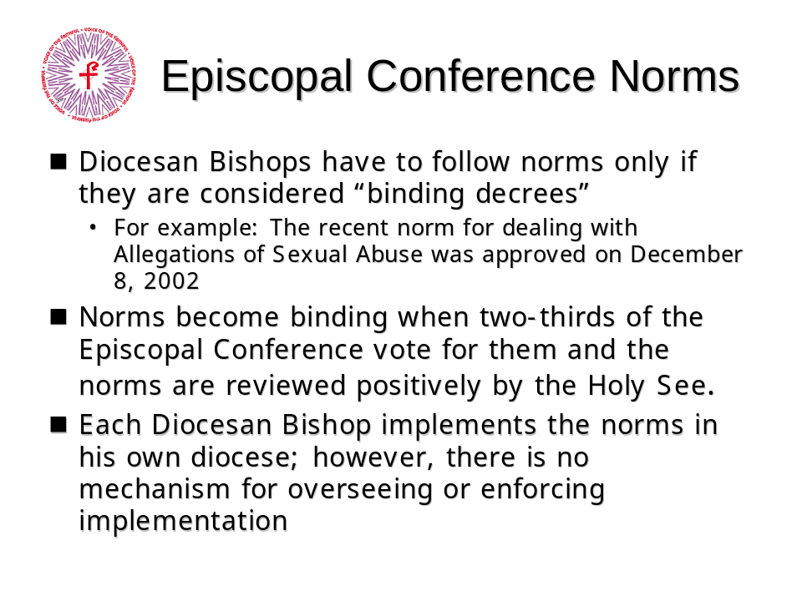

Narration
“To create a norm, the conference gathers and prepares the text of the norm and sends it to the Holy See. The Holy See reviews the text and returns either a positive review or a negative review. If the Holy See returns a negative review, the text is sent back to the Conference for additional work and the process begins again. If the Holy See returns a positive review, the Conference my promulgate the Norm. A positive review by the Holy See, however, is not an ‘approval’ of the Norm and does not obligate the Holy See to enforce the norm.
“Once a norm receives a positive review, it is voted on by the Conference. A 2/3 majority is required to make the Norm a Binding Decree. A binding decree requires all Bishops within the Conference to implement the norm, but no mechanism of enforcement exists, except informal pressure from fellow Bishops. This is sometimes referred to as ‘fraternal correction’. Some Bishops are resistant to this pressure, and chose not to follow Episcopal Conference Norms, even those considered binding.”

Example of a Norm
Essential Norms for Diocesan/Eparchial Policies Dealing with Allegations of Sexual Abuse of Minors by Priests or Deacons (Approved by the Congregation for Bishops, December 8, 2002) is an example of a USCCB norm.
For more information go to http://www.usccb.org

Governing Laws

Diocesan Statutes and Norms
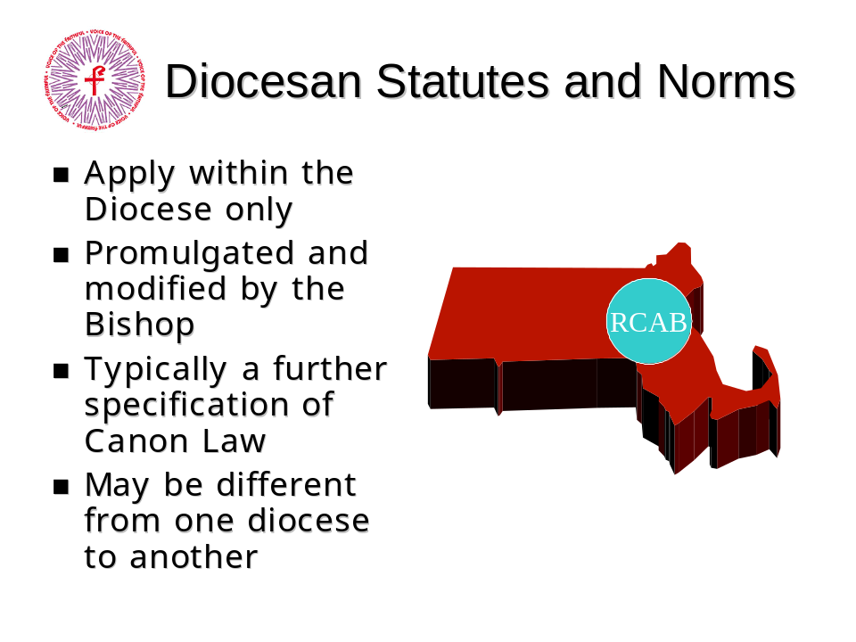

Narration
“On a more local level, a Diocesan statute can be created and promulgated by a diocesan Bishop within his diocese. The Bishop may modify Statutes and Norms as he sees the need. Suggestions for change may come from any level (including parishioners).
Diocesan statutes apply only within the boundaries of the diocese. As with Episcopal norms, they are usually a refinement or clarification of existing laws and may vary from one diocese to another.
An incoming Bishop may modify (and even eliminate) norms established by his predecessors, as long as his actions do not conflict with Canon Law.”

Governing Laws

Parochial Norms and Rules
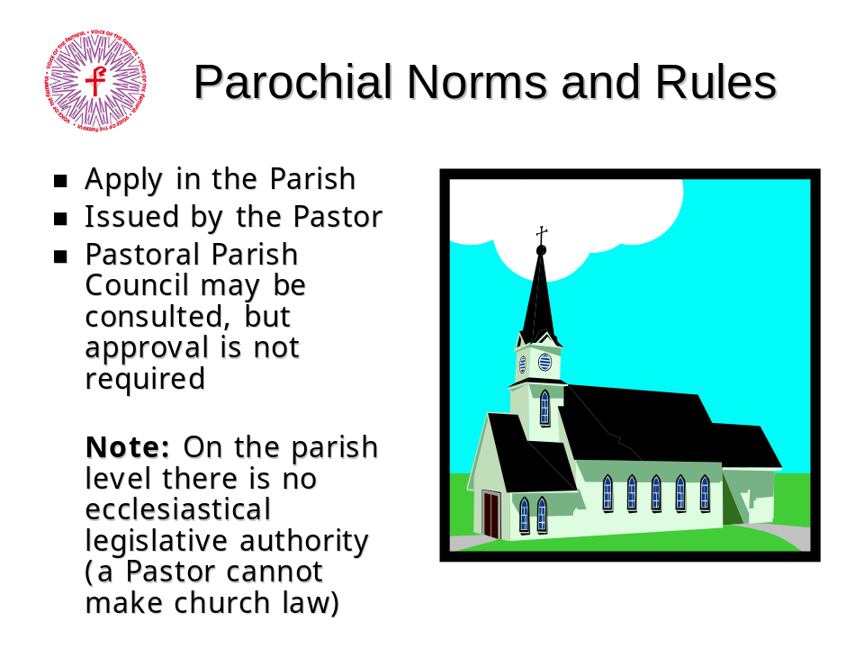

Narration
“Finally we come to parochial norms and rules. These apply only in the specific parish where they are adopted. Typically, these norms are for the governance of the parish, since Parochial norms have no ecclesial authority; that is, a Pastor cannot make church law.
The Parish Pastoral Council of other lay groups within the parish may play a consultative role in establishing these norms, if the pastor allows it and the Bishop does not object.
As with the other areas of governance, Parochial norms are usually a refinement or clarification. For example, the diocese may have a statute that requires every parish to have a parish pastoral council but leaves the composition, population, and governance of these PPCs to the individual pastors to codify. A local pastor may then assemble a group of people from the parish to create Foundation Documents to govern how the PPC is elected and it’s operation.”

Governing Laws

Example
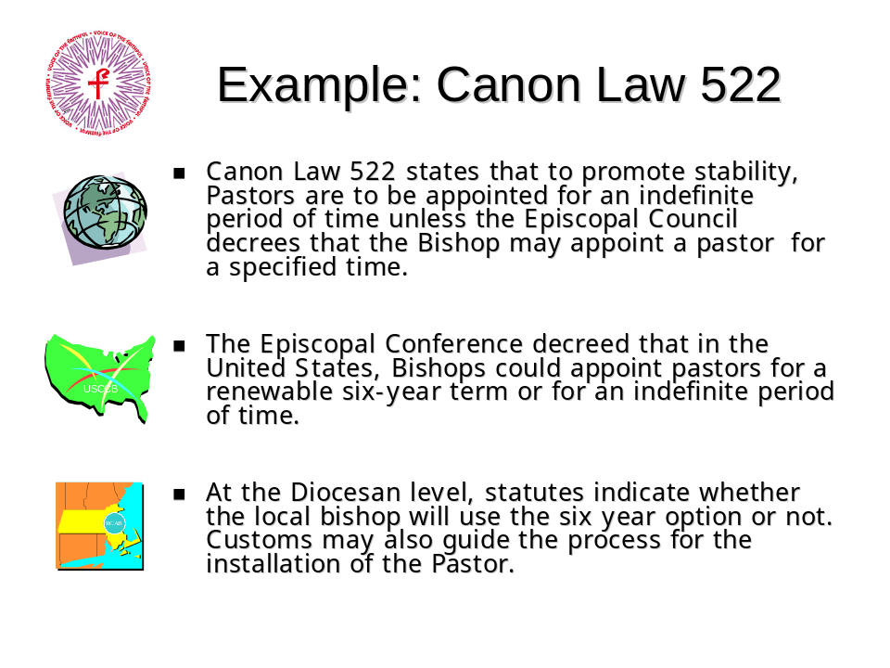

Narration
“Let’s take a look at an example to see how these different levels of governance interact.
Canon Law 522 determines that unless modified by the Episcopal Council, parochial pastors are to be appointed for an indefinite period of time. The USCCB decided that parochial pastors would be appointed indefinitely, or for a six year term. In the Archdiocese of Boston, the Bishop determined that pastors in that diocese would be appointed for a six year term. We see how each level refines Canon 522 to suit the needs of the region and diocese, while none of the refinements contradict or override the law above it.”

Governing Laws

Modification Process
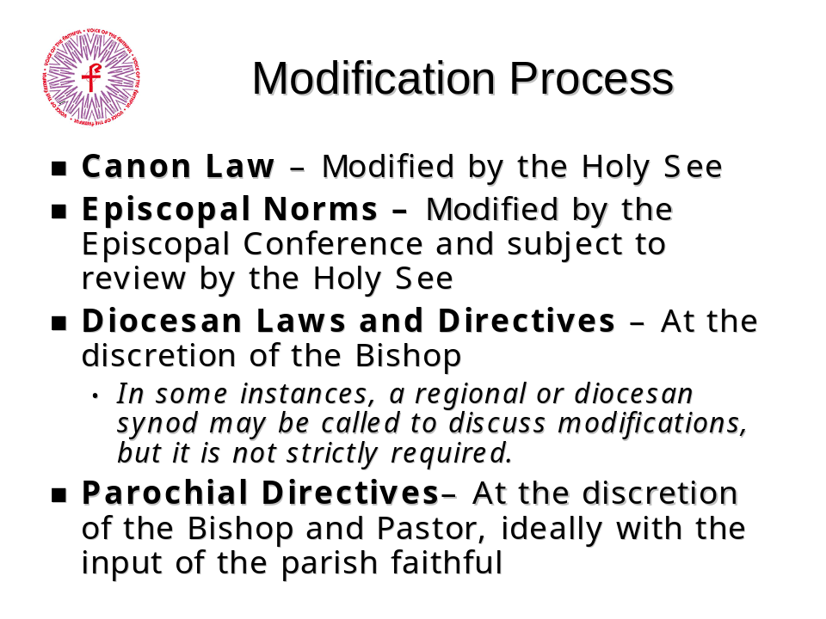

Narration
“Now that we see how the governing laws interact, how are they modified? Remember that the law must be promulgated by an authority. It is the same authority that has the right to modify the law. In the case of Canon Law, the Holy See has the sole authority to modify. Episcopal Norms are modified by the Conference, and Diocesan directives modified by the Bishop.
In all cases, there is no impediment for input from the laity, but there is no requirement for input either.”

Modifying Canon Law
Canon Law is changed is response to changes in the theology and life of the church. The 1983 Code of Canon Law codified the changes that had emerged fro the Second Vatican Council some 20 years earlier.

Governing Laws

Issues for Discussion
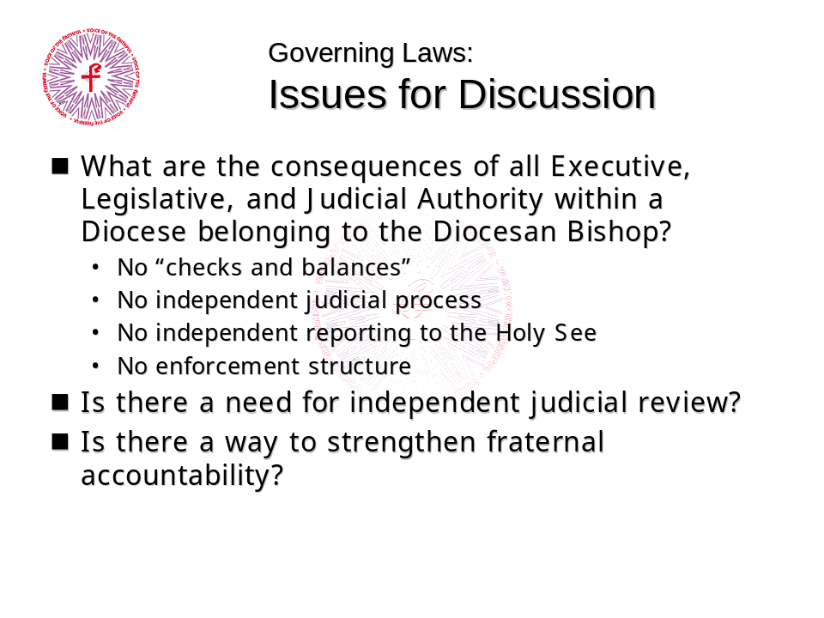

This information is for further consideration and discussion, which should provide an opportunity to envision new or more effective organizational structures for the Church.
The Bishop is the sole legislator of his own diocese, and although the Episcopal conference has the right to make decrees (such as the norms) for the whole conference, there is no mechanism in place to enforce implementation other than fraternal pressure from other Bishops, and no independent reporting of implementation to the Episcopal Conference or to the Holy See.
The lay faithful have some rights defined under Canon Law, but if a Bishop violates those rights, there is no legal remedy. This is similar to the status of the Declaration of Human Rights by the United Nations, which establishes human rights but has no mechanism in place to enforce these rights. The Constitution of the United States, on the other hand, has the Bill of Rights, and a court system to ensure the enforcement of these rights.
On a local level, parishioners are often permitted to participate in the process of crafting local norms for their parish within the bounds of Canon Law. Although still subject to the Bishop’s review and permission, there is much that can be done to enhance the role of the laity in the parish, including the formation of Safety Committees and drafting effective foundation documents for the Pastoral and Finance councils.

Offices, Titles, and Organizational Structure

Introduction


Narration
“In this section we’ll take a look at some of the offices, titles, and organizational structures of the church. We’ll learn about honorific titles and official roles, as well as how the structures interact with each other to form the infrastructure of the administration of the church.”
Offices, Titles, and Organizational Structures

Ordained Offices
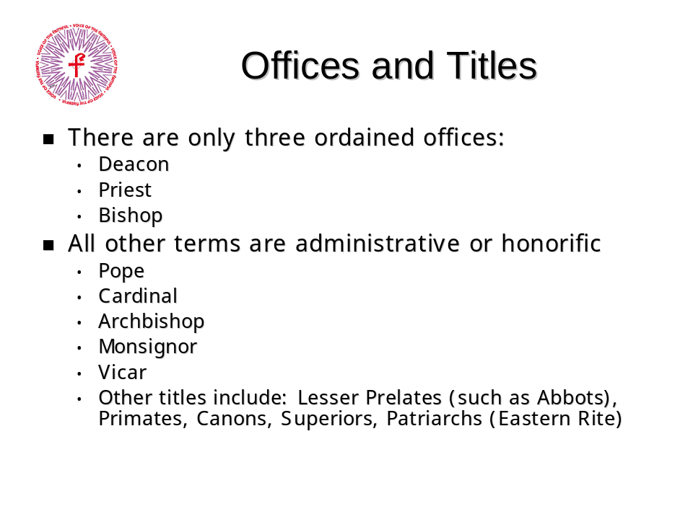

Narration
“One of the key points to understand in this section is that there are only three ordained offices in the Catholic Church: Deacon, Priest, and Bishop. All other titles are either administrative or honorific. The highest ordained office in the church is that of Bishop. A Bishop may be called the ‘Ordinary’ of the Diocese, indicating that he holds the authority to govern it. This authority may be held by someone other than an appointed Bishop in very rare instances. A Bishop of an Archdiocese is called an Archbishop, but Archbishop is not an ordained office, and the title does not indicate any additional authority or responsibility beyond those of any other Diocesan Bishop.
This slide lists some of the titles of the Latin Rite. The most recognized title, of course, is Pope. Among the official titles of the pope are, Supreme Pontiff (or Pontifex Maximus in Latin, originally the title of the high priest of the pre-Christian Roman religion), Servant of the Servants of God, Vicar of Christ, and Bishop of Rome.
Cardinal is a title given to a priest or Bishop selected by the Pope to serve in the College of Cardinals, an advisory body.
Other titles of the Latin rite are purely honorific, such as Monsignor.”

Offices, Titles, and Organizational Structures

The Holy See
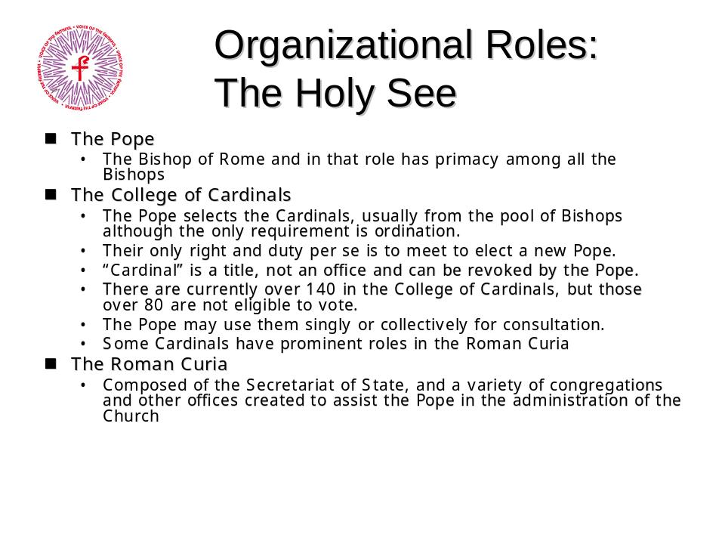

Narration
“The organization of the Holy See encompasses three primary parts; the Pope, the College of Cardinals, and the Roman Curia.
The pope has many other official titles in addition to Bishop of Rome, but it is his role as the Bishop of Rome which gives him primacy over the Universal Roman Catholic Church.
Although the only right and duty of a Cardinal per se is to meet with his fellow Cardinals to elect a new Pope, the Pope does use them informally for consultation, and they often play important roles in the Curia as well.
The Curia is composed of the Secretariat of State, and various Congregations and other offices which are given the task of assisting the Pope in the administration of the Church.”
Offices, Titles, and Organizational Structures

Number of Cardinals
As of October 2003, there were 194 Cardinals, 132 of whom were eligible to vote for the next Pope. For a complete list, see http://www.catholic-pages.com/hierarchy/cardinals_list.asp

The Roman Curia
Elements of the Roman Curia include:
- Secretariat of State
- Congregations (or Dycasteries), for example:
- The Congregation for the Doctrine of the Faith (formerly Congregation for the Holy Inquisition)
- Congregation for Divine Worship and the Discipline of the Sacraments
- Congregation for the Causes of the Saints
- Congregation for the Evangelization of Peoples
- Tribunals (such as the Rota)
- Pontifical Councils, for example:
- Pontifical Council for the Laity
- Pontifical Council for Promoting Christian Unity (includes Commission for religious relations with the Jews)
- Offices, Agencies, Commissions and Vicariates
For more information, go to http://www.vatican.va/roman_curia/
Offices, Titles, and Organizational Structure

Organizational Structure of the Church 1
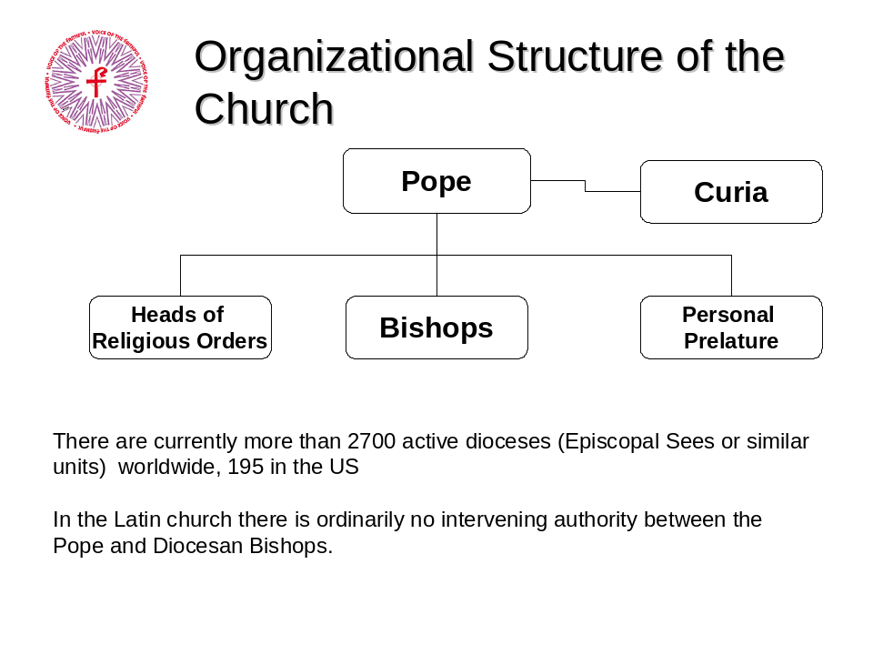

Narration
“This chart is a simplification of the organization of the church.
At the top are the Pope and the Curia. The Curia are the executive offices of the Pope. The authority of the Curia comes from the Pope. The Pope asks the Curia to study some issue, they do so, and the conclusion goes back to the Pope for promulgation. At the top of all major offices in the Curia there is a Cardinal. Cardinals receive authority from the Pope for the administration of the Church. The Curia’s function and extent of power is dependent on the Pope.
There are currently more that 2700 active Dioceses (Episcopal Sees or similar organizations) worldwide. There are 195 in the US. Diocesan Bishops are appointed by the Pope, and in the Latin Rite there is ordinarily no intervening authority between the Pope and the Diocesan Bishops.”
Offices, Titles, and Organizational Structure

Organizational Structure of the Church 2
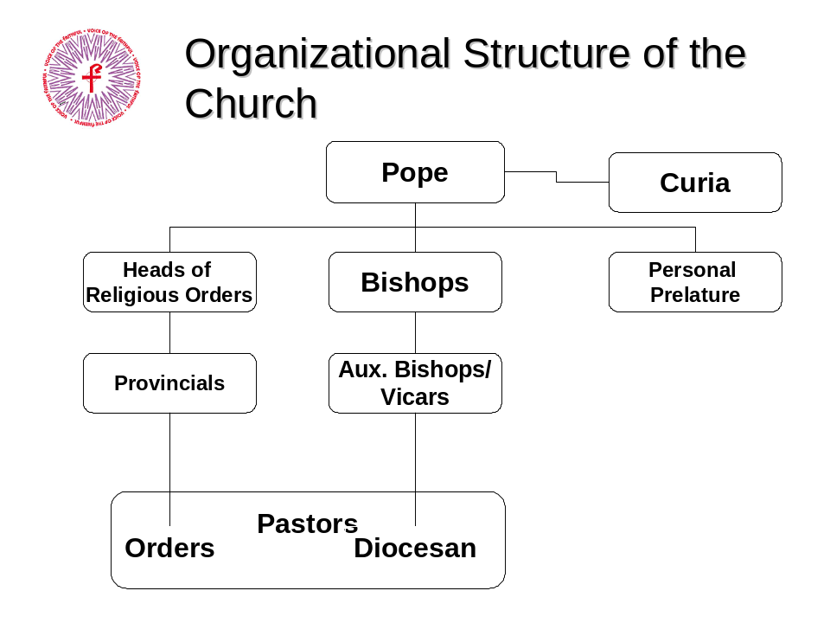

Narration
“Each diocese is governed by an individual (the “Ordinary”), who holds sole executive, legislative and judicial authority within the diocese. This is almost always the Diocesan Bishop, but in rare circumstances the ordinary may be someone else designated by the Holy See. The Bishop often initiates the appointment of Titular Bishops, requesting that they be ordained Bishop and appointed to work with him in his diocese. The Holy See can impose one if it chooses, however. Authority flows from the Bishop to the Auxiliary Bishops. They do not ‘report’ to the Pope, they report to the Bishop.
On the same level in the organizational structure of the Church with Diocesan Bishops are Heads of Religious Orders, and Heads of Papal Personal Prelatures. Religious orders include the Franciscans, Dominicans and the Jesuits. Examples of Personal Prelatures are Opus Dei and the Legionaries of Christ. A member of an order must get the approval from both the Provincial (local head of the order) and the Diocesan Bishop to become a pastor of a parish. Pastors who are members of religious orders have some measure of independence from the Diocesan Bishop, since they do report directly to him. The Bishop can request that the Provincial remove a member of on order from the Diocese, however.”

Offices, Titles, and Organizational Structure

Archdiocese
An Archdiocese is traditionally the most prominent diocese among several neighboring diocese, and is usually situated in a major metropolitan area such as New York, Boston, Philadelphia, Chicago, Los Angeles and so on. That is why an older term for Archdiocese is Metropolitan See. Bishops of dioceses that fall within the group that includes an archdiocese do not ‘report’ to the Archbishop, as opposed to Auxiliary Bishops who do report to the Archbishop or Bishop. Metropolitan is an infrequently used arcane term; the modern title is Archbishop. The Metropolitan presided over a Metropolitan See, as an Archbishop presides over an Archdiocese.

Titular Bishops
All Bishops are ordained as Titular Bishops or Bishops with a title to a see of the ancient church, and they maintain this title throughout their lives. After their ordination they may be assigned to be Bishop of a modern diocese, or they may be assigned by Rome to a Diocesan Bishop who vests authority in the Titular Bishop making him an Auxiliary Bishop.

Offices, Titles, and Organizational Structure

Organizational Roles – The Diocese
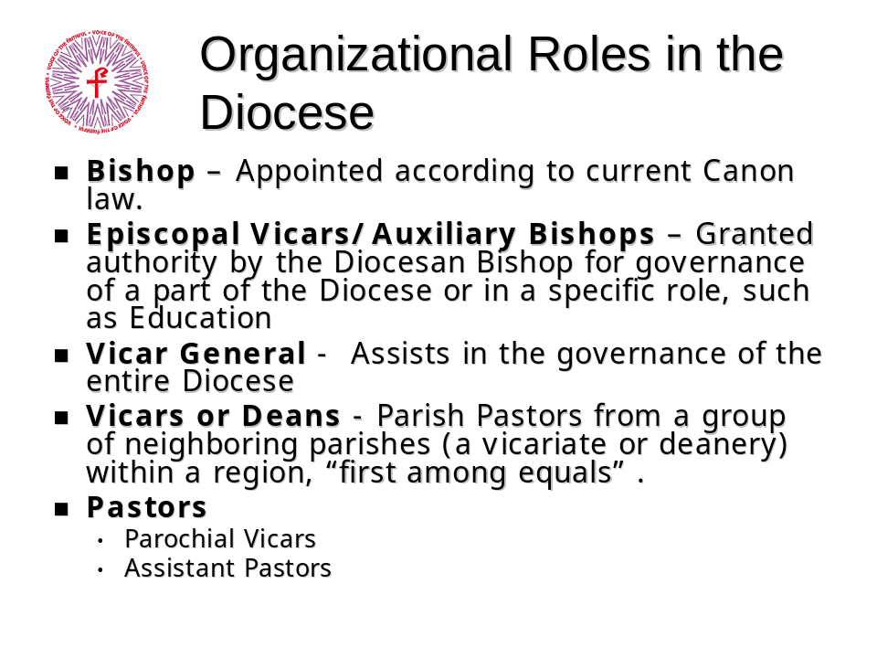

Narration
“Organization of a Diocese is similar to the organization of the Church at large: The Bishop, appointed by the Pope, holds authority over the diocese. Bishops may designate vicars, who are entitled to exercise Episcopal authority on the Bishop’s behalf. These vicars may be Auxiliary Bishops or Priests, or even lay people who serve as leaders within the diocese. Auxiliary Bishops are most frequently seen in large dioceses, where it is necessary to lead a large number of Catholics. For example, the Bishop may appoint a Vicar General to assist in the governance of the entire diocese. He may appoint an Episcopal Vicar to be responsible for education throughout the diocese, or the he may appoint an Auxiliary Bishop to the governance of a region of the diocese. The Bishop has a broad range of options open to him in administering his diocese.
At the parochial level, the Diocesan Bishop assigns a Pastor to a parish. Parishes may be bound together into groups called Deaneries or Vicariates. Each of these is assigned a leader, called a Dean or Vicar, usually a pastor from one of the parishes in that group. The leader is the first among equals and holds no authority over the other pastors in that group. Parishes may be loosely organized into smaller groups called clusters.
The Pastor is in charge of his parish, but the Diocesan Bishop may assign Parochial Vicars and Assistant Pastors to help him in running the parish.”

Notes
- Before 1916, the United States was considered a Mission and Bishops were appointed on the recommendation of local ordinaries.
- The seat or see of a Diocesan Bishop is in the Diocesan Cathedral
Offices, Titles, and Organizational Structure

Issues for Discussion
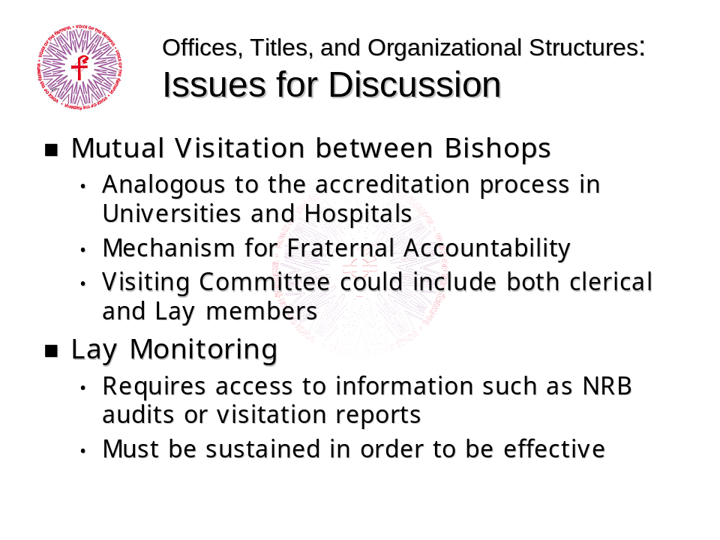

This information is for further consideration and discussion, which should provide an opportunity to envision new or more effective organizational structures for the Church.
In the absence of independent judicial review of a Diocesan Bishop’s actions, or of independent reporting, other mechanisms or structures may be required to ensure safety of children, . One of the results of VOTF’s organizing efforts has been to bring lay groups from many different dioceses into contact. This communication between groups has enabled the sharing of ideas and experiences, learning from each other’s successes, and sometimes failures. While this informal process has helped many groups, a more formal process at the ecclesial level may be beneficial.

Offices, Titles, and Organizational Structure

What is Mutual Visitation?
Mutual Visitation doesn’t exist now, but such a process could be a mechanism for encouraging renewal where it is needed. Currently the Diocesan Bishop has absolute authority within the Diocese. No one comes into a Diocese and reports independently; all reports to Rome go through the Diocesan Bishop. Needed change is very unlikely to come from within the Diocese under these circumstances.
The concept of Mutual Visitation is similar to the accreditation process that occurs in hospitals and universities throughout the country. Such an accreditation visit triggers a valuable process of self-examination in the organization preparing for it. Such a visitation could provide a mechanism for needed renewal and for Fraternal Correction among Bishops. A group formed from peer communities comes into an organization and visits and talks with elements of the organization (in this case, laity, clergy, religious orders, etc.). The visiting group then prepares a visitation report.
. While the diocesan Bishop retains full authority in his own diocese, the process of fraternal accountability comes into play. For example, the delegation may seek to discover if structures and processes for child protection are in place in a diocese, and review the steps taken to implement the processes. They may suggest methods which have worked elsewhere, and help the local Bishop set up and implement proven practices. Where remarkable weaknesses are identified, the visitation report could include an action plan for correcting them.

Lay Monitoring
Lay monitoring can also play a role in ensuring that Bishops within their Dioceses are living up to the promises they have made in the Norms and other instances. In order to be effective, however, this monitoring must be part of a continuing process, and requires access to information on the status of diocesan structures such as committees established by the diocese to monitor accusations of abuse or financial mismanagement.

The Laity

Introduction


Narration
In this section we learn what the roles of the laity as prescribed by Canon Law and other documents from Vatican II.
The Laity

Existing Lay Structures
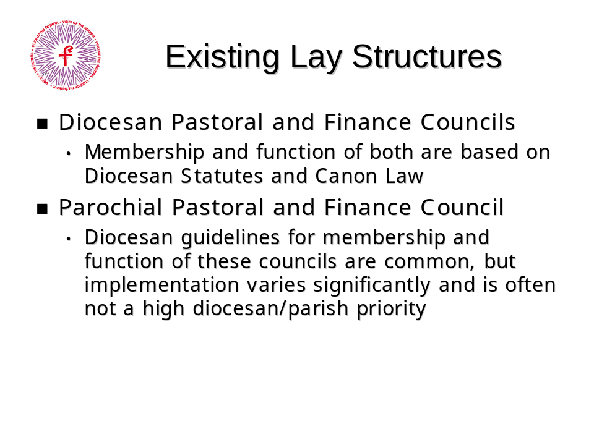

Narration
“There are two significant structures prescribed by Canon law which must or may include lay members: Finance Councils and Pastoral Councils. Canon law requires Finance Councils at both the parochial level and at the diocesan level. Pastoral Councils are not required, but Canon Law sets up guidelines for both the Parochial Pastoral Council and the Diocesan Pastoral Council. As we learned in previous sections, Canon Law is usually flexible so that it may be adjusted to the needs of specific diocese. While Canon Law leaves the option of Pastoral Councils open, it requires Finance Councils to exist.”
The Laity

Diocesan Finance Councils
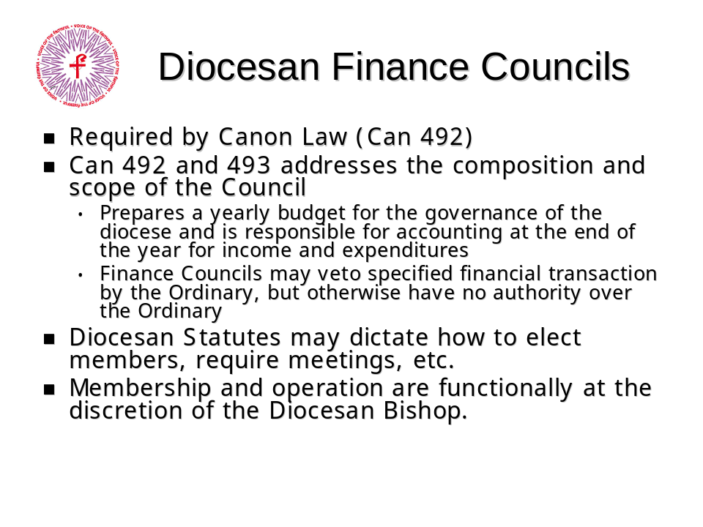

Narration
“Diocesan Finance Councils are mandated by Canon 492. The law expresses the requirement, but diocesan statues may govern how to elect members, the conduct of meetings, agendas, etc. Membership and operation of the Finance Council are at the discretion of the Bishop.
It is important to note that both the Finance Council is not specifically designated by Canon Law as a lay structure; it specifies only the faithful.
VOTF has prepared a set of operating Principles for Diocesan Finance Councils. The Principles are intended to:
- Provide for transparency and accountability with respect to all diocesan financial matters;
- Provide for substantive and broad lay involvement in diocesan financial affairs; and
- Avoid conflict of interests in diocesan financial matters.”

The Laity

Text of the Canons
Can. 492 §1
In each diocese a finance committee is to be established, presided over by the diocesan Bishop or his delegate. It is to be composed of at least three of the faithful, expert in financial affairs and civil law, of outstanding integrity, and appointed by the Bishop.
Can. 492 §2
The members of the finance committee are appointed for five years but when this period has expired they may be appointed for further terms of five years.
Can. 492 §3
Persons related to the Bishop up to the fourth degree of consanguinity or affinity are excluded from the finance committee.
Can. 493
Besides the functions entrusted to it in Book V on 'The Temporal Goods of the Church', it is the responsibility of the finance committee to prepare each year a budget of income and expenditure over the coming year for the governance of the whole diocese, in accordance with the direction of the diocesan Bishop. It is also the responsibility of the committee to account at the end of the year for income and expenditure.

Note
The council can deny consent to the Bishop to expend funds over a specified amount. They have a veto right, but cannot impose anything on the Bishop. The Bishop CANNOT override a veto. This is one very rare limit on the authority of a Diocesan Bishop.

The Laity

Parish Finance Councils
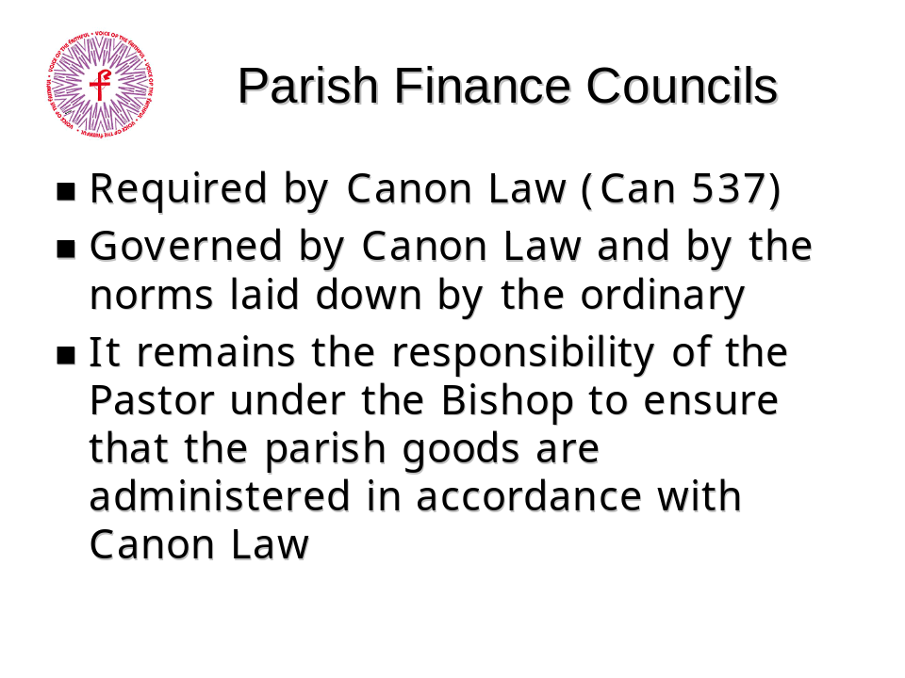

Narration
“Parish Finance councils are required by Canon 537. They are governed by the law in the same way that Diocesan Finance councils. It remains the responsibility of the Bishop and the pastor to ensure that the goods of the parish are administered in accordance with Canon law.
VOTF has proposed a set of operating Principles for Parish Finance Councils which are parallel to those for Diocesan Councils.”

Text of the Canons
Can. 537
In each parish there is to be a finance committee to help the parish priest in the administration of the goods of the parish, without prejudice to can. 532. It is ruled by the universal law and by the norms laid down by the diocesan Bishop, and it is comprised of members of the faithful selected according to these norms.
Can. 532
In all juridical matters, the parish priest acts in the person of the parish, in accordance with the law. He is to ensure that the parish goods are administered in accordance with canon 1281-1288
The Laity

Diocesan Pastoral Councils
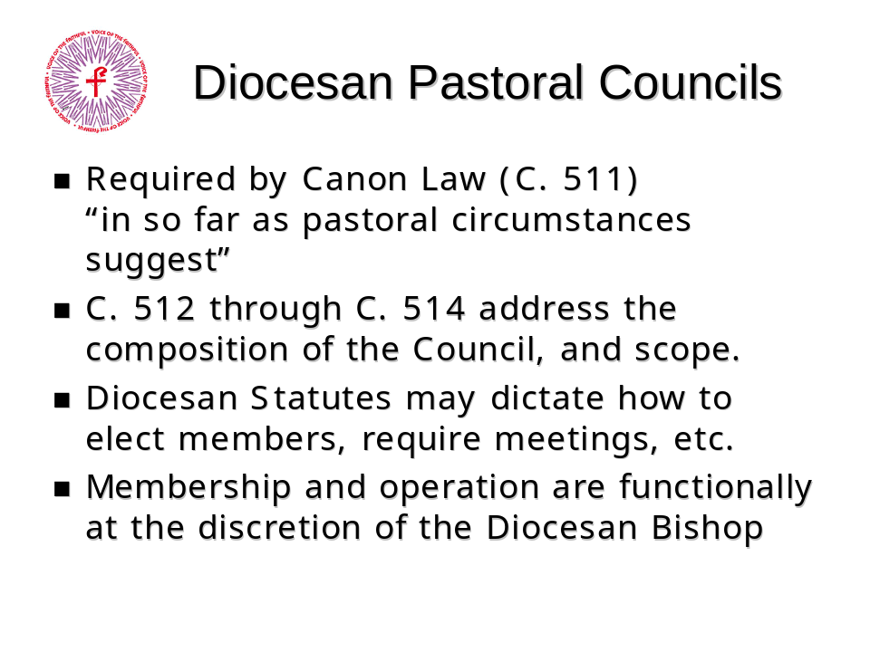

Narration
“Although Diocesan Pastoral Councils are required by Canon 511, the law provides for Bishops who do not wish to establish Diocesan Pastoral Councils. In the United States, Diocesan Pastoral Councils are the norm, rather than the exception.
Canons 512 through 514 prescribe the composition and scope of the pastoral council, but membership and operation are still at the discretion of the Bishop. Many dioceses around the country have statutes which dictate electoral processes and protocols for the Diocesan Pastoral Council.
The Laity

Text of the Canons
Can. 511
In each diocese, in so far as pastoral circumstances suggest, a pastoral council is to be established. Its function, under the authority of the Bishop, is to study and weigh those matters which concern the pastoral works in the diocese, and to propose practical conclusions concerning them.
Can. 512 §1
A pastoral council is composed of members of Christ's faithful who are in full communion with the catholic Church: clerics, members of institutes of consecrated life, and especially lay people. They are designated in the manner determined by the diocesan Bishop.
Can. 512 §2
The members of Christ's faithful assigned to the pastoral council are to be selected in such a way that the council truly reflects the entire portion of the people of God which constitutes the diocese, taking account of the different regions of the diocese, of social conditions and professions, and of the part played in the apostolate by the members, whether individually or in association with others.
Can. 512 §3
Only those members of Christ's faithful who are outstanding in firm faith, high moral standards and prudence are to be assigned to the pastoral council.
Can. 513 §1
The pastoral council is appointed for a determinate period, in accordance with the provisions of the statutes drawn up by the Bishop.
Can. 513 §2
When the see is vacant, the pastoral council lapses.
Can. 514 §1
The pastoral council has only a consultative vote. It is for the diocesan Bishop alone to convene it, according to the needs of the apostolate, and to preside over it. He alone has the right to make public the matters dealt with in the council.*
Can. 514§2
It is to be convened at least once a year.
* An alternative translation from the Latin for this phrase is “He alone has the right officially to pronounce [promulgate] the decisions of the Council”. It is not clear that the original text requires secrecy concerning the deliberations or the decisions of the Council.
The Laity

Parish Pastoral Council
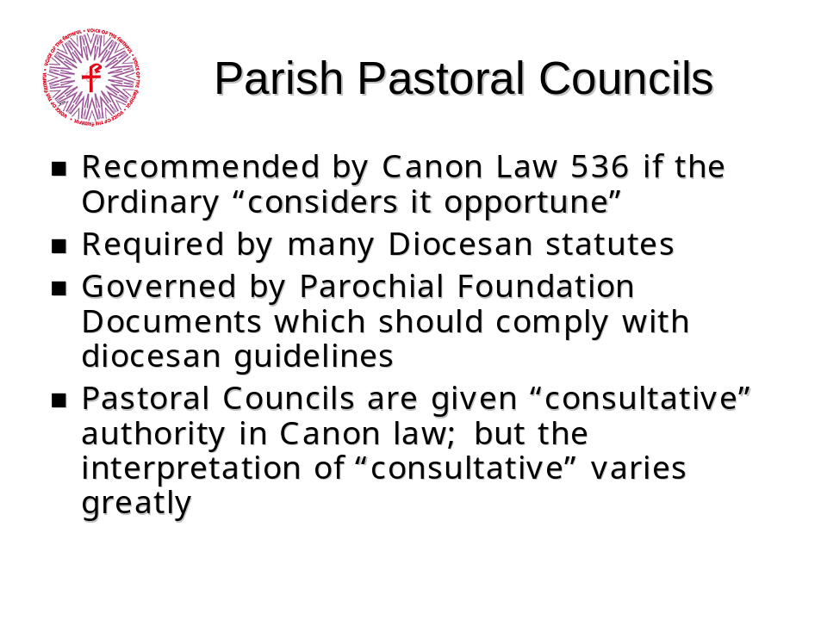

Narration
“Parish Pastoral Councils are recommended by Canon Law 536 but not required. Many diocesan statutes require Parish Pastoral Councils however. The PPC may be governed by diocesan statutes or by parochial foundation documents (in compliance with any diocesan statutes).
The role of the parish pastoral council is described by canon law as ‘consultative.’ The term ‘consultative’ has been interpreted differently in many circumstances. The term seems to occupy a space somewhere between ‘advisory’ at one end of the spectrum and ‘deliberative’ at the other.
The Holy Father has provided some insight into the term in his document “At the Dawn of the New Millennium” where he states:
‘To this end, the structures of participation envisaged by Canon Law, such as the Council of Priests and the Pastoral Council, must be ever more highly valued. These of course are not governed by the rules of parliamentary democracy, because they are consultative rather than deliberative; yet this does not mean that they are less meaningful and relevant.’
The Laity

Text from Novo Millennio Ineunte (At the Dawn of a New Millennium), January 2001
“Communion must be cultivated and extended day by day and at every level in the structures of each Church's life. There, relations between Bishops, priests and deacons, between Pastors and the entire People of God, between clergy and Religious, between associations and ecclesial movements must all be clearly characterized by communion. To this end, the structures of participation envisaged by Canon Law, such as the Council of Priests and the Pastoral Council, must be ever more highly valued. These of course are not governed by the rules of parliamentary democracy, because they are consultative rather than deliberative; yet this does not mean that they are less meaningful and relevant. The theology and spirituality of communion encourage a fruitful dialogue between Pastors and faithful: on the one hand uniting them a priori in all that is essential, and on the other leading them to pondered agreement in matters open to discussion.
“To this end, we need to make our own the ancient pastoral wisdom which, without prejudice to their authority, encouraged Pastors to listen more widely to the entire People of God. Significant is Saint Benedict's reminder to the Abbot of a monastery, inviting him to consult even the youngest members of the community: ‘By the Lord's inspiration, it is often a younger person who knows what is best’. And Saint Paulinus of Nola urges: ‘Let us listen to what all the faithful say, because in every one of them the Spirit of God breathes’.”
The Laity

Issues for Discussion
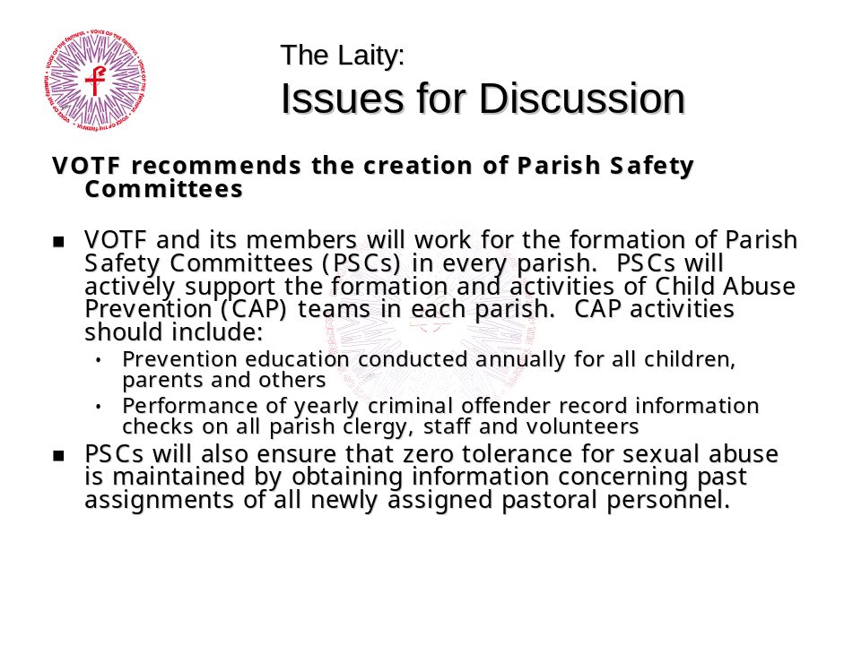

This information is for further consideration and discussion, which should provide an opportunity to envision new or more effective organizational structures for the Church.
This section has covered some of the areas where the laity are given a role by Canon Law in the administration of the Church. Other documents, such as the Dogmatic Constitution of the Church, Lumen Gentium, provide clear recognition of the role of the laity in the Church, not just as passive observers, but as active participants using the gifts God has given us.
VOTF has committed itself to work for active, collaborative, effective and representative Pastoral and Finance Councils in every parish. In addition, VOTF has proposed the establishment of Safety Committees in every parish. Safety Committees lie well within existing Canon Law, and could be established by individual Bishops, and some have do so.
In the last section, we discussed the possibility of lay monitoring, in this section, some specific issues are raised: Does your diocese have a Finance Council? Does your Parish? How are the members chosen? Does your diocese mandate a Pastoral council? If it does, does your parish have one? How does your pastor interpret the ‘consultative’ role of the PPC? Does your parish have a Safety Committee? Does your diocese mandate Safety Committees?

The Laity

Safety Committees
Discussion Points
- How can you best implement a Safety Committee in your parish?
- Discuss how the safety committee is distinct from a diocesan ordered program (such as Child Abuse Prevention team) and how the two can work together.

Finance Council Guidelines
VOTF has prepared operating principles for Finance Councils, both on the diocesan level and the parochial level. These guidelines are not confrontational, but rather are designed to collaborate better with our clergy and to improve accountability in administering these temporal goods. This can help ensure that the church is not vulnerable to scandal. Please visit the VOTF website for more information on the Finance Council Principles.

Pastoral Parish Councils
The composition, scope, and role of the Parish Pastoral Council varies wildly from parish to parish and diocese to diocese. VOTF carried out a national survey on PPCs and what makes them effective. A presentation describing the survey results can be found on the VOTF website.

Putting it All Together

Introduction


Narration
“In this section we’ll review the relationships between parochial and diocesan organizations and areas where the laity interact with the administration.”

Putting it All Together

The Diocese
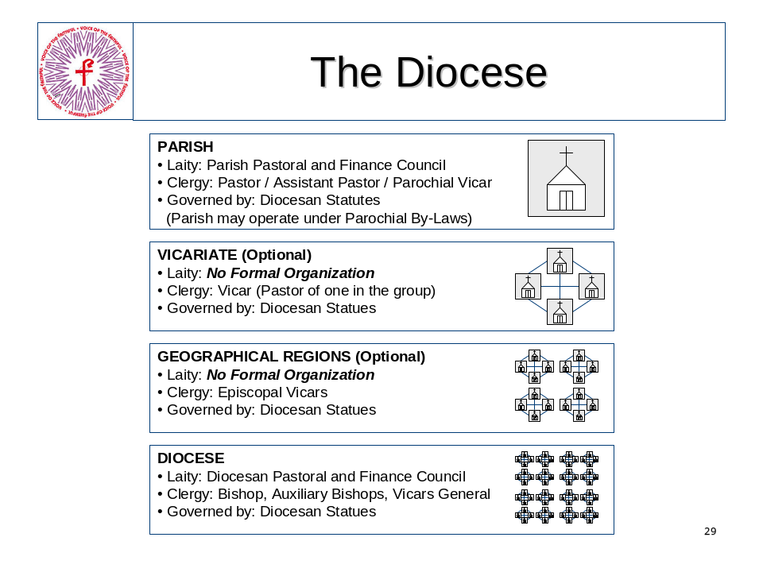

Narration
“In previous slides we’ve looked objectively at the structures that govern the Church from the Holy See down to the diocese and parish level. Now let’s look at things from a more personal perspective.
We start with our own parish. Here the laity are most visibly involved, not only in the physical support of the parish, but in the pastoral and finance councils. The parish is led by the Pastor and whoever he appoints to help him. The parish is governed by diocesan statutes and parochial by-laws.
Your parish may belong to a group of local parishes, called a deanery or vicariate. The group of parishes may share resources (such as a youth minister) and leverage each other’s resources. There is no formal lay organization at this level, although there is a clerical leader of the group.
The parish or parish group may belong to a region designated by the Bishop. These regions may be led by an Auxiliary Bishop. There is no formal lay organization at this level.
The parish, group, or region are part of the diocese. The Bishop is the sole authority in the diocese. At the diocesan level, there is a mandated Finance Council, and in most diocese, a Pastoral Council.”

Putting it All Together

Existing Structures
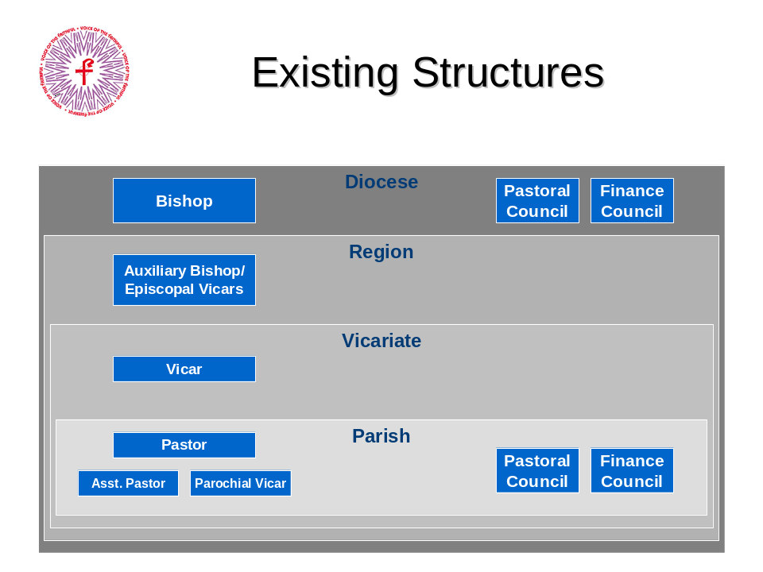

Narration
“We can see how the parish is ‘nested’ within the administrative structure of the diocese. On the left we see the clerical structures that govern that group or sub-group. On the right, we see the current lay structures that exist in that group or sub-group.”

Putting it All Together

Recommended Structures
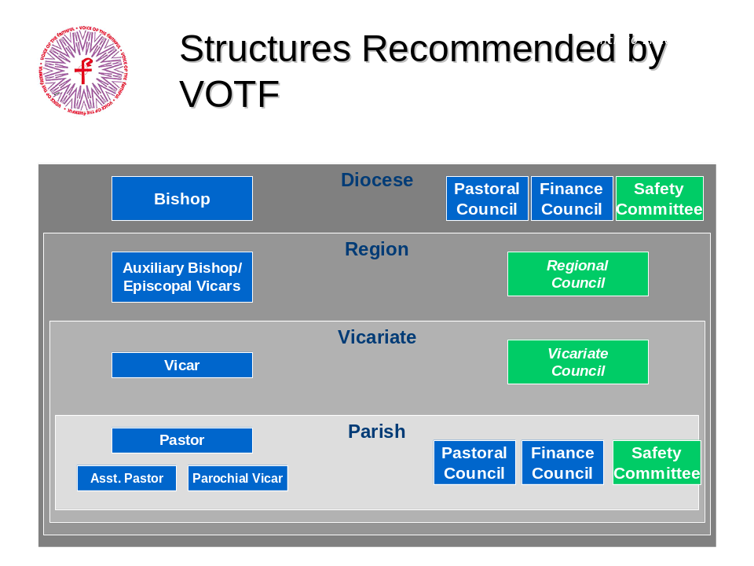

Narration
“This slide is for discussion purposes only, and shows the structures proposed by VOTF in addition to those currently required or recommended under Canon Law.
VOTF recommends the creation of lay bodies at every level, including safety committees at the diocesan and parochial level. Where a diocese is divided by regions and vicariates, lay bodies at those levels should work with the clerical leadership, particularly in areas where resources are shared across parish boundaries.

Summary

Introduction


Narration
“This section summarizes the key points from the preceding sections and reviews the discussion points.”

Summary

Instructional Summary
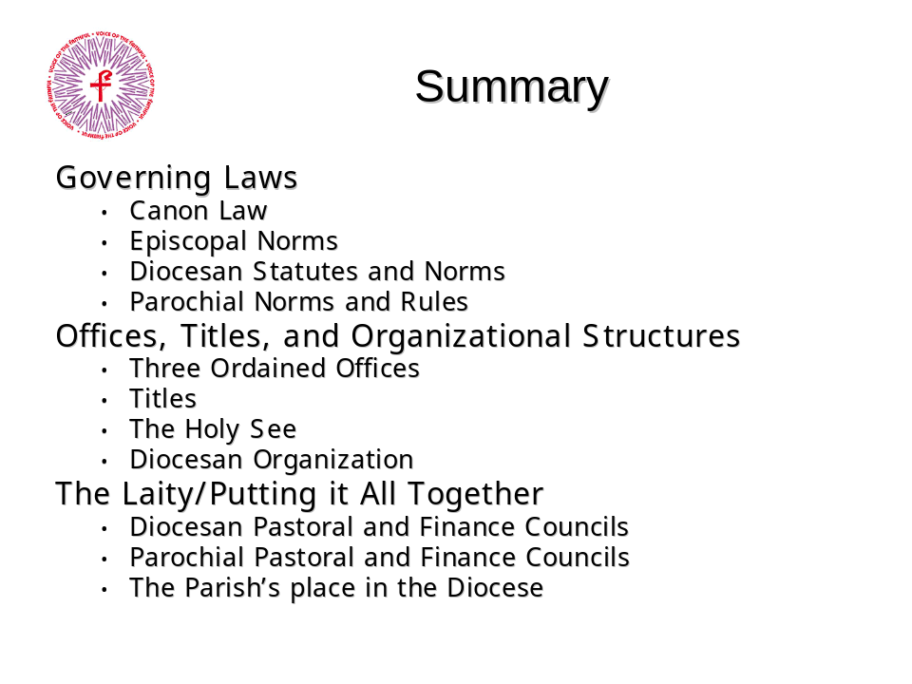

Narration
“The Catholic Church is governed by Canon Law at the worldwide level, Episcopal Norms, Diocesan Statutes, and Parochial By-laws. No law may contradict or supersede the law above it.
There are only three ordained offices in the Church, Bishop, Priest, and Deacon. There is no intervening authority between a Bishop and the Pope. The Bishop holds all executive, legislative and judicial authority in his diocese.
The laity play an important role in the governance of the Church through bodies created by Canon Law, including Diocesan Finance and Pastoral Councils.”

Summary

Discussion Summary
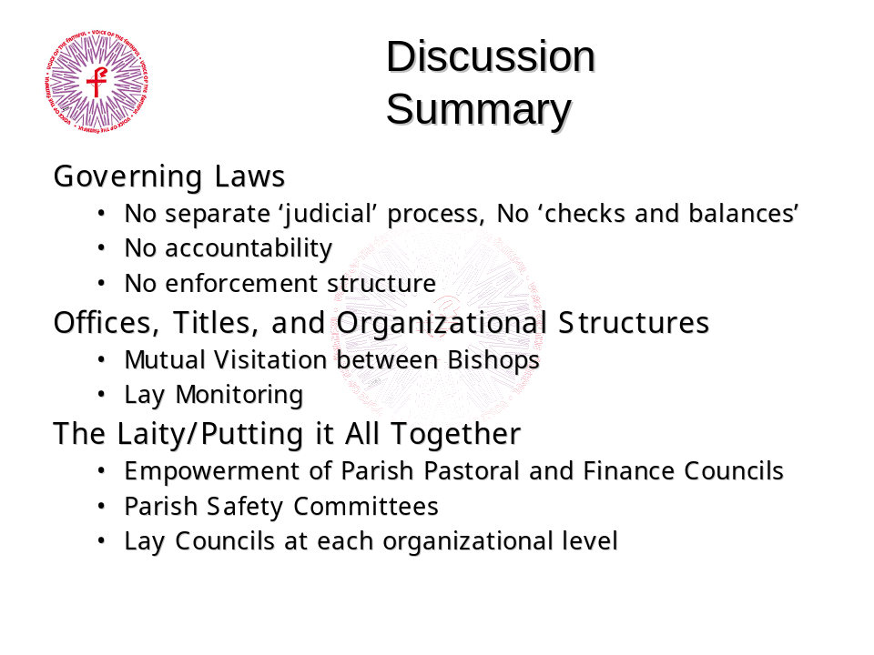

Discussion Points
- The current organizational structures do not preclude the participation of all the faithful, but the cultural implementation of the structures emphasize a top-down hierarchical approach.
- We propose that with active participation by the laity, these same structures allow not only for communication, but consultation and collaboration with all the faithful.
- Active participation by the laity in Church structures is essential to enable any change in Church administration and culture.
- A continuum of lay councils such as proposed here may facilitate representative lay involvement from the parish level upwards.
Summary

A Final Word from JP II:


